S k y l i n e H i g h S c h o o l
Anatomy and Physiology II
Updated for the 2016-2017 school year

Instructor: Mrs. Cheryl T. Reed, MEd, NBCT, ATC/L DO NOT PRINT OFF SYLLABUS!
Office Hours: Before school, B lunch and/or after school
Office Location: Classroom 1306
E-mail: reedc@issaquah.wednet.edu
Phone: Email is the preferred method of communication
Class Website: www.mrsreedsclass.weebly.com (accessible through Skyline’s website)
Course Fee: none

Course Description
This course will provide basic healthcare information fundamental to any healthcare profession. The course will cover the circulatory, lymphatic, respiratory, digestive and urinary systems. Students are encouraged to join CLUB MED so that they may compete at state and national competitions sponsored by Health Occupation Students of America (HOSA) and the Washington Career & Technical Sports Medicine Association (WCTSMA).

Instructional Vision

To prepare students for the rigorous course work that will inevitably follow in pursuing a medical program and/or career. Students completing A&P in high school will have a competitive advantage over their peers as they will have already been exposed to the difficult nature of the curriculum, performing better in their college courses and being more marketable for medical program admittance. For those students not pursuing medicine as a career, the course will provide them an in depth understanding of the human body that will benefit them the rest of their lives. They’ll have a better understanding when communicating with healthcare providers regarding their own health and well-being, an invaluable skill as so many Americans are not educated about their bodies.

Materials for Class
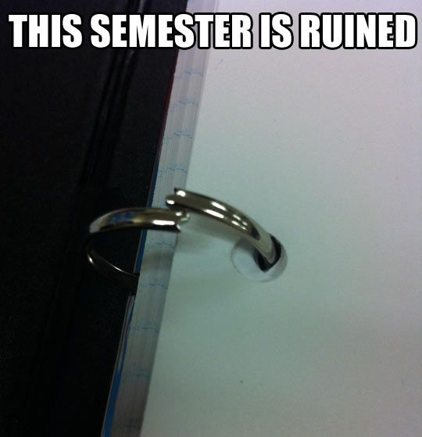
- Students need to have a separate 1½-2” binder for this course which may be stored in class.
- Writing utensils of choice, though pencil is encouraged
- We use an in-class set of texts, therefore, textbooks will not be checked out to students. There are numerous on-line resources available on the course website.
- Students are encouraged to use their student planners to record assignments and important dates in addition to classroom whiteboards and the course website.
- A white lab coat (provided) shall be worn each day of class.

Grading Scale
A 92.5-100% (Excellent) | B- 79.5-82% | D+ 66.5-69%
A- 89.5-92% | C+ 76.5-79% | D 62.5-66% (Below Average)
B+ 86.5-89% | C 72.5-76% (Average) | D- 59.5-62%
B 82.5-86% (Good) | C- 69.5-72% | F Below 60% (Poor)

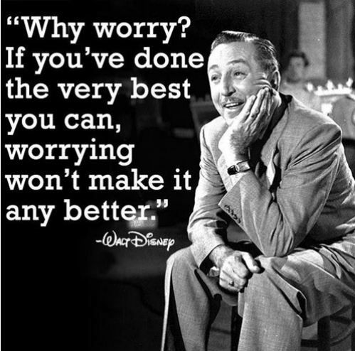
Grade Category Weights
Coursework 40%
Assessments 30%
Semester Portfolio & Job Shadow 10%
Employability Skills (punctuality, collaboration, respect, etc.) 10%
Final Exam (comprehensive) 10%

Coursework
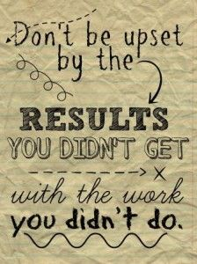
Students are expected to perform at their very best on coursework, paying special attention to detail, thoughtfulness and thoroughness. Coursework may be evaluated merely for completion, for quality relative to that of their peers in class and/or for response accuracy. Coursework is expected to be complete and handed in on time. It is the student’s responsibility to get any missed coursework/information from the whiteboard, website and/or their classmates after an absence and submit completed work in accordance with the student handbook. Coursework submitted after a due date may be eligible for the full credit possible so long as a valid Universal Pass accompanies it. The semester portfolio and job shadow are exempt from Universal Passes.

Assessments

A variety of assessment formats are used to assess student learning (labeling, multiple choice, short answer, essay, true/false, etc) and may vary from assessment to assessment. Assessments are administered electronically using Google Forms. When finished with an assessment, students are encouraged to read a book, listen to quiet music and/or work quietly on coursework. If a student misses a test due to an absence, it is the student’s responsibility to make an appointment to take the test before school or during first lunch. Make-up assessments will not be given during class time. Tests can be made up throughout the semester until Friday, June 02, 2017. Assessments not made up by then will be scored as a zero. Click here, for helpful note taking and study tips.

Semester Portfolio & Job Shadow

Class participants will complete a job shadow of a medical professional to be included in their portfolio. It is important that students understand that when the due date is established, all portfolios and job shadows turned in AFTER the due date will receive NO credit, NO exceptions. If a student is going to be absent due to illness or other personal reasons, an able person must turn the portfolio into the office on or prior to the due date. Lastly, to receive any credit for their job shadow, all 10 hours of observation must be completed. Any job shadow that is less than 10 hours will not receive any credit. In addition to the job shadow, students will need to keep all handouts and assignments organized in their course binder (score guide to follow, indicating order of documents). The semester portfolio will be due Friday, May 26, 2017 and the job shadow is due Friday, June 02, 2017.

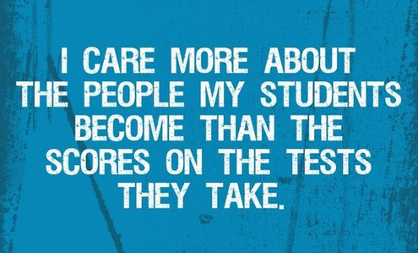
Final
A comprehensive final will be administered at the end of the semester and will consist of 100+ multiple-choice questions. It is strongly recommended that students keep all notes and handouts organized and kept together, not only for their semester portfolio, but for referral/studying at the end of each semester. Click for here for tips to keep your notes organized for future reference.

Employability
Employability reflects the punctuality, cooperation, participation and behavior of a student in class. As this is a CTE course, it is important to practice and model skills desirable of employees in a workplace. A student earns 10 points per day towards their employability category. Employability points may be lost if students are not modeling the following (not an all-inclusive list):
- Absences are excused through the attendance office (0pts earned for unexcused absences)
- Student remains in classroom unless dismissed by the teacher (0pts earned for truancy)
- Student arrives to class on time or has a teacher’s/office note if late to class (5pts lost if tardy)
2pts lost per behavior not modeled:
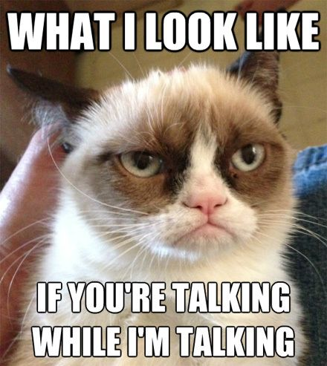
- Appropriate language used (no cursing, bringing down others, shouting, etc)
- Professional behavior and demeanor towards others
- Participation in class activities/discussions
- Respectful of others and others’ property
- Follows instructions
- Follows lab safety rules and cleans up work space
- Awake and engaged in class
- Does not vandalize school property (i.e. does not write on desks)
- Correctly stows technology after use
- Consumes only nutritious foods/beverages in class
- Keeps personal electronic devices in their bag until instructed to use them (see below)

Personal Electronic Devices
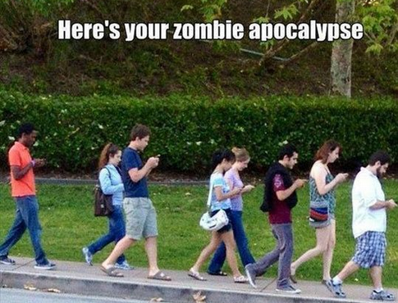
Out of respect for themselves, the teacher and their classmates, students are asked not to have their electronic devices out or audible. From time to time it would be appropriate to use their electronic devices in class. Such opportunities will be communicated to students or students may ask the teacher if it is appropriate to use them. Students will be expected to follow ISD policies regarding personal electronic devices. Unauthorized use of electronic devices will result in the following ramifications in addition to a loss of citizenship points:
- First offense will result in the confiscation of the device until the end of the period
- Second offense until the end of the day
- Third and future offenses will result in the device being kept by the teacher (in a locked drawer). The device will only be returned to a parent/guardian when they pick up the device outside of school hours.

Absences
Students are considered absent if they arrive 15 minutes after class has begun, as per the student handbook, whether excused or not. When a student is absent, upon returning to school, he or she must get an office note that either designates the absence(s) as excused or unexcused, even if the absence was pre-arranged with the attendance office (excludes events/activities in which an absence pre-arrangement form is completed). It is the office note that students must show the teacher to be admitted to class.

Truancies
Students are truant if they leave class without permission, fail to show up to class but are obviously at school and/or leave the classroom when a substitute teacher is late or does not show up. There is no 15-minute rule that students may leave if a teacher/substitute fails to arrive before hand…don’t fall for the myth!

Tardies
The tardy policy is enforced as per the student handbook. Being tardy for this course means a student is out of his or her seat at the start of class as indicated by the classroom clock. If a student is late due to another class/teacher, they should provide a note from that class/teacher to excuse their tardy and retain their citizenship points.

Technology Guidelines and Policies
Technology is an important part of any education and this course is no exception. Students will be required to use a variety of programs throughout the course including, but not limited to, Windows Office applications, Dropbox, Google Drive, PhysioEx and interactive web tools. Students lacking a reliable computer, printer and/or internet access need to notify the instructor immediately. Please remember the school’s library is a resource for computers, printers and internet access, as are the ten computers in our classroom.

The instructor cannot be held accountable for late work resulting from the following circumstances:
- A printer running out of ink (email to instructor if no other option available)
- Home internet down (public/school libraries have access)
- A computer crashing (thus, why we use a web-based program to store files)

Extra Credit Opportunities
Several opportunities exist to earn extra credit points:
- Pictures—Students may submit anatomical/physiological pictures in electronic format (e-mail attachment, disk, CD, memory stick, etc), videos, apps and animations for 2-10 points a piece of extra credit. There is a 10 point maximum. Materials must be able to be used by the instructor for course purposes. Applied to Assignments Category.
- Spartans Gone Green—Students can earn up to 2pts per Friday by bringing in the designated items listed on their Gone Green Log. To earn these points, the student and their log must be present in class the day credit is awarded. It is not up for debate if the teacher does not approve the items for points. See the Spartans Gone Green Guidelines on the back of your Gone Green Log for further details. Applied to the Assessments Category.

Scholarships
Scholarships are available through the Washington Career and Technical Sports Medicine Association (WCTSMA) and Health Occupations Students of America (HOSA). Check the CLUB MED website or the CLUB MED page on the course website for more information and take advantage of these opportunities.

Leadership: CLUB MED
All health sciences students are encouraged to participate in state and national organizations by joining CLUB MED. The student led club is affiliated with Health Occupations Students of America (HOSA) and the Washington Career and Technical Sports Medicine Association (WCTSMA). Visit the HOSA and WCTSMA websites for leadership opportunities and offices held by students. There are also leadership opportunities within CLUB MED itself. For further information contact Mrs. Reed or visit the CLUB MED website.

Teacher Expectations of Students
Students will respect themselves, their fellow students, classroom guests and the instructor at all times.
- Keep your work organized so you can find assignments and notes easily
- Respect other people’s belongings, space and rights to an quality education
- Follow instructions provided by the instructor, substitute teachers and guest speakers
- Do not draw on desks or otherwise vandalize school property
- Keep cell phones/iPods quieted and stowed in your bag during class

Student are responsible for having with them all necessary materials needed in order to participate in class, including admit slips for absences.

Students are responsible for turning in their assignments in on the date due prior to the start of class, unless otherwise instructed by the teacher.
- Use your student planner to keep a record of assignments and when they are due
- Familiarize yourself with Dropbox and how to upload assignments to avoid technological difficulties resulting in a late submissions
- Utilize resources available to you to stay on top of your homework, like our course website

Students are to be in their seats by the start of class as indicated by the classroom clock and not leave the classroom unless excused by the teacher.
- Remember the teacher dismisses class, not the clock
- Make sure your watch and/or cell phone is in sync with the classroom clock to avoid tardies
- Driving students, leave early enough to park and get to class on time whether coming from home or lunch

Students will act as responsible and professional members of the Skyline learning community.
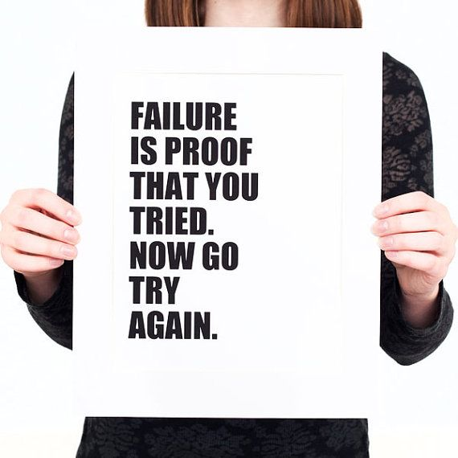
- When struggling, seek help by emailing or meeting with the instructor; utilize your classmates and research to help you as well
- Give yourself adequate sleep and good nutrition to perform your best in school and your other activities
- Remain organized to help manage your time and reduce stress
- Support your peers in their learning, it will reinforce your own learning
- Appreciate school as an opportunity to grow and improve yourself; it is a privilege not all people are afforded
- “Never, EVER give up!” Do not be afraid of mistakes or failure…that is truly where learning lies

Lab Safety Rules
During this course there may be a number of experiment/lab opportunities involving chemicals and lab equipment. Most of the chemicals we use in class are safe and pose little to no threat to health. However, whether working with benign or hazardous materials/equipment, it is important to adhere to lab safety rules (classroom and school district) as if all labs/equipment are potentially dangerous.
- No horseplay! Horseplay will result in the removal from the lab and a zero on the assignment.
- Follow teacher instructions exactly—if you’re not sure about something, ask!
- Alert teacher to problems, equipment malfunction and/or injuries immediately
- Know how to use lab safety equipment (fire extinguisher, fire blanket, wash stations, etc)—we will cover the use and location of such equipment in class
- Wear safety goggles at all times when working with materials that could splash or otherwise get into the eyes
- Long hair should be pulled back (shoulder length or longer)
- Avoid awkward transfers—carry smaller quantities to your lab station
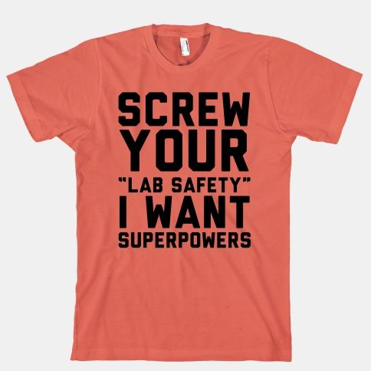
- Allow hot objects to cool or use appropriate protective equipment (gloves, clamps, tongs, etc)
- Carry chemicals defensively to avoid accidents—watch where you’re going and what other people are doing
- As our classroom is not a typical science lab, all personal belongings need to be at the front of the room to avoid tripping, destruction of property and other similar incidents
- The teacher will inform students how to properly dispose of chemicals/lab wastes
- Dress appropriately—No open toed shoes or baggy clothes
- Always leave your lab station clean and wash your hands

Student Expectations of the Teacher
Students can expect the teacher to have genuine concern for and care about students as individuals.

Students can expect to be adequately prepared for exams through thorough instruction.

Students can expect to have engaging lessons that utilize a variety of formats to enhance student interest and learning.

Students can expect to have a teacher who is well organized and accountable for assignments turned in by students.

Students can expect to have a teacher who is objective, equitable and fair in their assessment of student work and effort.

