CLUB MED Clothing Order Form

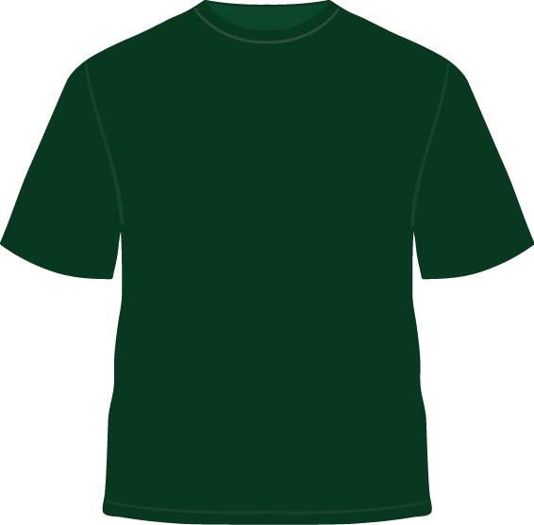
Member’s Full Name: _______________________________________

_________ Hooded Sweatshirt—$21.00
Size: XS S M L XL
Color: Black Skyline Green
_________ Name to be printed on back (an additional $4):
________________________________________________
_________ Long Sleeve Tee—$12.00
Size: XS S M L XL
Color: Black Skyline Green
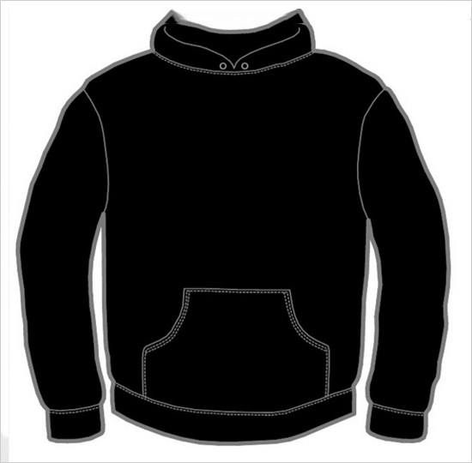
_________ Name to be printed on back (an additional $4):
________________________________________________
_________Basic T-Shirt—$9.00
Size: XS S M L XL
Color: Black Skyline Green
_________ Name to be printed on back (an additional $4):
________________________________________________

_____________ = TOTAL (Checks payable to SHS)

Order Agreement:
In signing below, the student/student’s family assumes responsibility for
covering the cost of the clothing ordered above and will not hold CLUB
MED accountable for covering the expense should the student/student’s
family decide they no longer wish to purchase club clothing. Submission
of this signed order form constitutes agreement to such terms.

Parent/Guardian Signature: __________________________________________ Date: _______________
(Required to place order)

Order forms due to Mrs. Reed (room 1306)
by Wednesday, January 31st

