BioCollage Assignment
Criteria
- Your collage should reflect your interests, likes, passions, hobbies, etc. in a manner that is appropriate for school and not offensive to peers/teacher (your Biocollage will be used as the cover for your Health binder so…)
- FIRST or LAST name should be clearly visible on collage (spelled out with magazine clippings)
- Pictures/words/letters should come from magazines with the exception of 3 “special items” (i.e. photographs you’ve taken, tickets, on-line images you’ve printed off, etc.); “special items” are not required
- The entire piece of cardstock should be covered with clippings; no cardstock color visible (and no coloring over the cardstock to hide it)
- Pictures/words/letters should be cut out neatly and glued flat to the cardstock
- Your collage should demonstrate creativity, flare, fun, artistic flavor…EFFORT in other words
- Due Wednesday and is worth 10pts

Helpful Tips and Information
- Magazines and gluesticks are available to borrow; see Mrs. Reed if you have a need for either
- Please ask family members before cutting up magazines that do not belong to you
- Gluing your pictures/words to your cardstock should be the very last thing you do so that you can work with your images/clippings until your collage looks as you want it too

Examples
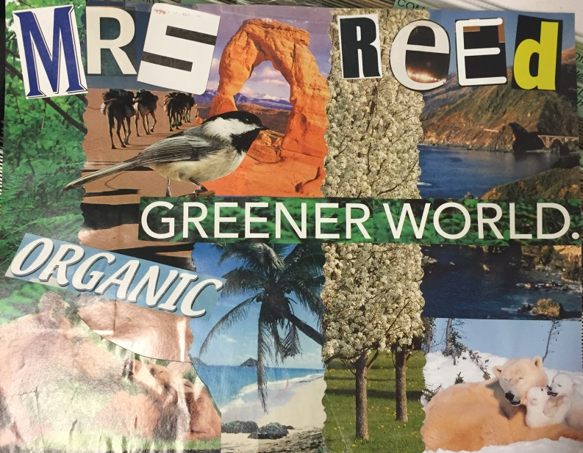
10/10
Images are cut out neatly
Images reflect that which is important to creator; layout is pleasing to the eye
Only magazine clippings used; glued down flat with no corners curling up
The cardstock is entirely covered; no cardstock color showing
Name is large and clearly visible
It’s fairly clear what this person is interested in, but there could be more!
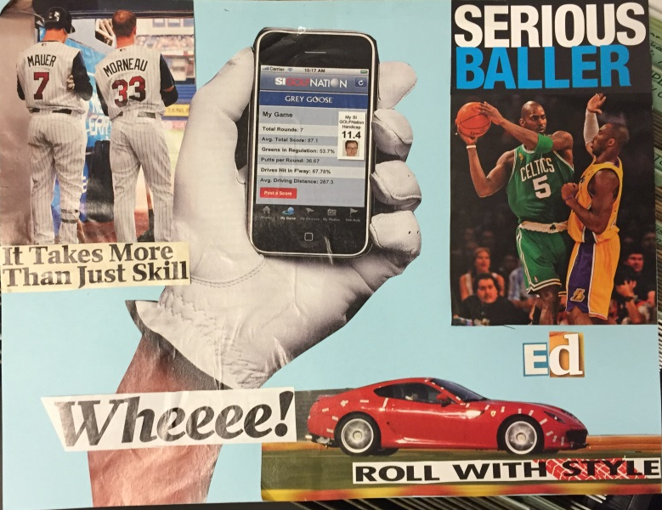
7-8/10
A corner or two is not thoroughly glued down
Displays some creativity in layout; uses different clippings to create a unique image
Name is present, but is small; if there were more pictures it would be lost in them
Too much cardstock (blue) not covered
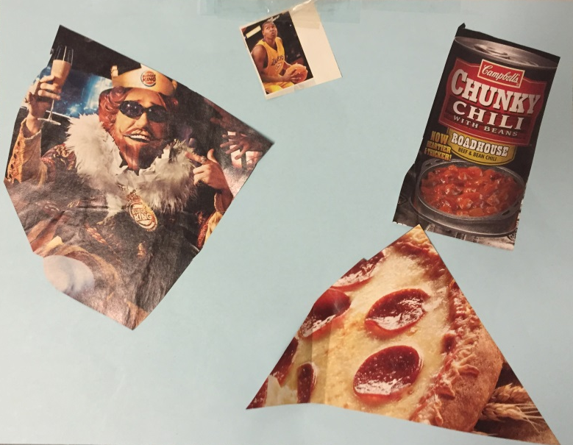
6/10
Do not have a clear understanding of what this student is all about based on effort and images present
No thought or creativity to image layout
No student name present
Images are hacked out, not neatly cut out
WAY too much cardstock visible; only 4 images
Clippings are not thoroughly secured to the cardstock with glue

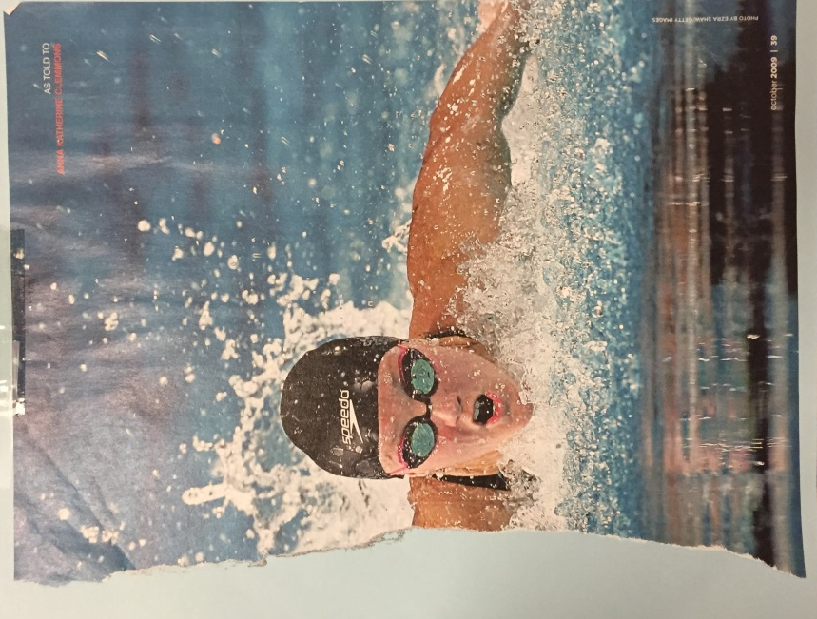
1/10
I hope this “collage” does not need an explanation for its poor score…

