Course Procedures and Expectations
Updated May 1, 2020

Office Hours:
I will maintain virtual office hours from 2:00 to 3:00pm Monday-Friday. Office hours are for student use to get responses to questions needing a quick response. Depending on the number of questions that come in, office hours may change. I will communicate via Remind if my office hours change.

Communication
Course Website—I live and breathe through my course website! It is your go to resource for updates and materials. Please refer to it each school day. I’m trying to return to the schedule I maintained while school was open. This means my website will be updated with the day’s lesson plans no later than the start time for each of my three classes:
- Sports Medicine by 11:20am
- Health by 12:15pm
- Personal Finance by 1:10pm
Remind—I would encourage students to download the Remind app on their phones. It’s free and an efficient means of communicating with me. I’ll be sending announcements via Remind. It will also be a means by which I will be keeping track of student engagement.
Email—This will remain a means of communication for both students and parents/guardians, though it may take me a little longer to reply to emails versus Remind messages.

Grading
As far as student work to be completed is concerned, I will be communicating on my website what are essential learnings and supplemental activities/resources.
- Essential Learnings = “Must do” and/or graded student activities/assignments to be entered in Skyward
- Supplemental Activities/Resources = Pieces that students are encouraged to complete to support their essential learning, but are not required or scored

Per the Issaquah School District - This term students will earn letter grades as outlined in the syllabus by their teacher. It is important to note that in alignment with OSPI’s new guidance, students will not earn grades lower than the grade they had at the closure of school (adjusted mid-term 3 grades). All students will have the opportunity to earn a higher grade by engaging meaningfully with their coursework. No students will earn F’s but will earn a letter grade (A, B, C or D) or an incomplete.

Examples of what student grades might look like given individual circumstances:
- Student 1 had a B at the closure in Biology and that student works very hard through the closure and through the teacher’s assessment of the student’s performance of the essential new learnings, the student receives a B or higher.
- Student 2 had a B+ at the closure, but, despite engaging with the teacher and the content, struggled with some of the new content and remote essential new learning. That student will still have a B+ at the end of the term.
- Student 3 had a C at the closure and could not engage with the coursework at all. The teacher has no way to assess the essential learning with nothing turned in. This student will earn an Incomplete and work with his or her counselor to engage in one of our credit recovery options (like summer school, an on-line course offering or another credit recovery option appropriate for that student).
- Student 4 had an F at the closure and could not engage with the coursework. This student will earn an Incomplete and work with his or her counselor to engage in one of our credit recovery options (as noted in the example above).
- Student 5 had P/F grading in his or her IEP. That student will remain eligible to earn a P or incomplete grade.

For my classes, a student will earn an incomplete if they are barely engaging in essential learnings provided, regardless of what their baseline grade was prior to the closure. “Engagement” will be based on a student:
- Attempting at least 90% of the essential learning assignments/activities
- Responding to teacher emails/texts in a timely manner and/or reaching out to the teacher as needed; essentially demonstrating engagement through communication
If a student has a letter grade at MT3, or March 12th, and they do not engage in learning as indicated above through the end of the year, they may be awarded an Incomplete and a plan will be developed for course completion (i.e., summer school, on-line school, etc.). Students/families will be notified in advance if a student was earning a letter grade MT3, or March 12th, and their Sem. 2 grade will be an Incomplete.

Class/Student Work Time
It has been communicated to families that high school students will be expected to complete lesson/coursework in approximately 180 minutes each school day. As we are on a seven period schedule, we have approximately 25 minutes per period in which teachers can provide instruction and/or students are to complete assigned activities. That is, teachers can engage in direct instruction for approximately 25 minutes (i.e. a video), but could not expect/require students to do any further work (i.e. answer follow up questions regarding the video) outside the 25 minute lesson for a given day. Using the video and follow up questions example, if a teacher wanted the follow up questions to be completed for a score to be entered into Skyward, they would have to be assigned/completed during a different day’s 25 minute period. Another situation could be the video is the “essential learning” for the day and the follow up questions “supplementary” as defined above.

Coursework Submission
There may be activities and/or worksheets students need to submit digitally, but are/were originally paper copies (particularly assignments from before the closure). Scanning paper documents with a scanner is preferred for students who have a functioning scanner at home. For those who do not, there are ways to make a single file out of multiple pictures taken with your phone. SmallPDF.com is simple to use, BUT it will only allow you to do two merges per hour for free (you DO NOT need to sign up for the “Free Trial” to merge files, FYI). TIP: Do not use your phone to create a PDF file…it can be messy and/or not work.

To make a PDF file from pictures taken of your work, follow these steps:
- Take an up close, clear picture of each side of the document/assignment (one picture for each side) on a flat surface with your phone positioned directly over the document and parallel to the flat surface it’s on. Save your pictures to your device, Dropbox or Google Drive.
- From a computer, go to https://smallpdf.com/merge-pdf. You should be able to choose your image files from your computer/device, Google Drive and/or Dropbox by clicking the dropdown menu arrow next to the “CHOOSE FILES” button.
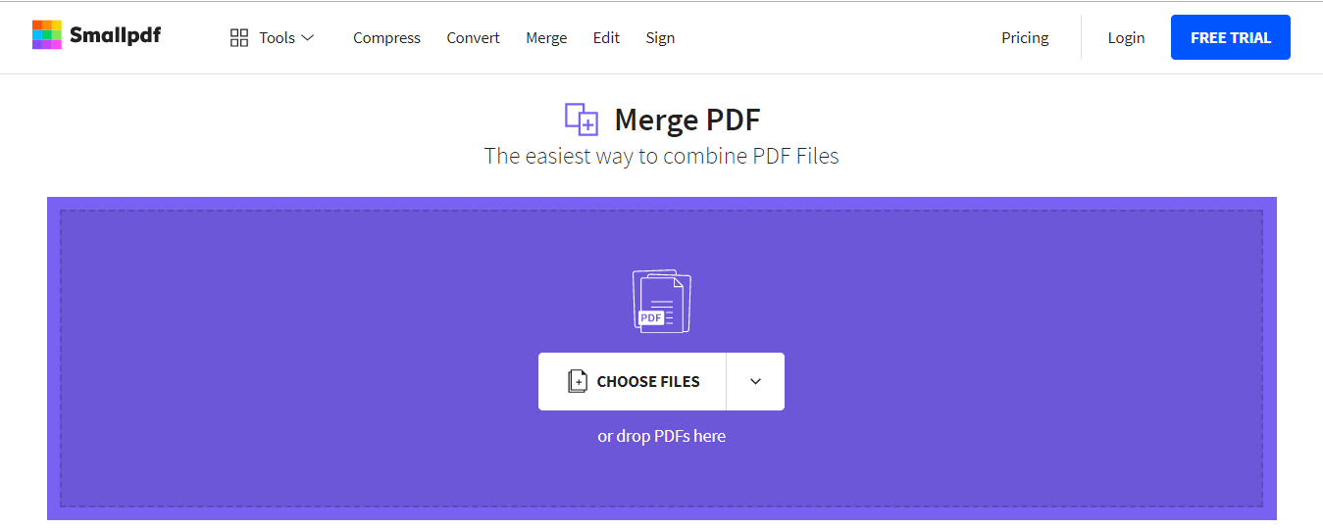

- Upload all the pictures you wish to have merged into one file, clicking “ADD MORE” as needed. Once all images are uploaded, you will be able to move them into the correct page order if needed by simply clicking on an image and moving it where you want.
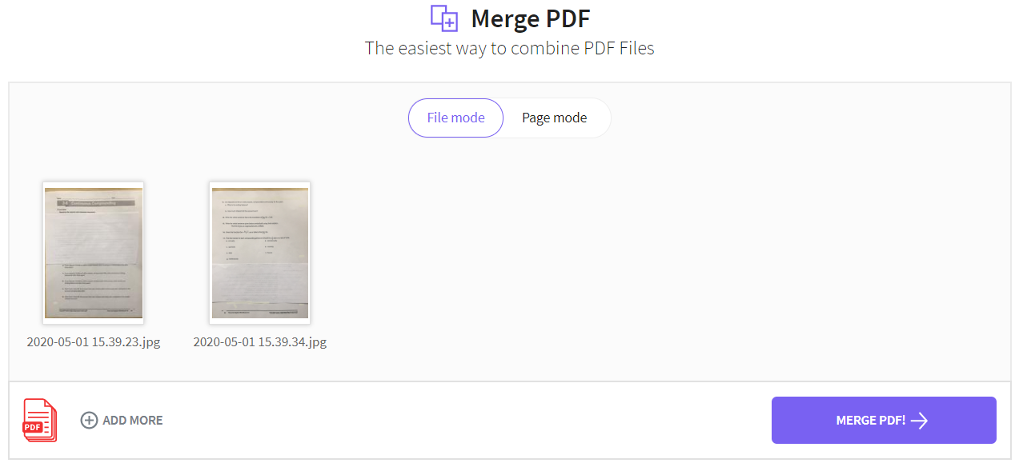

- Click the “Merge PDF!” buttons and your file will be generated.

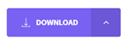
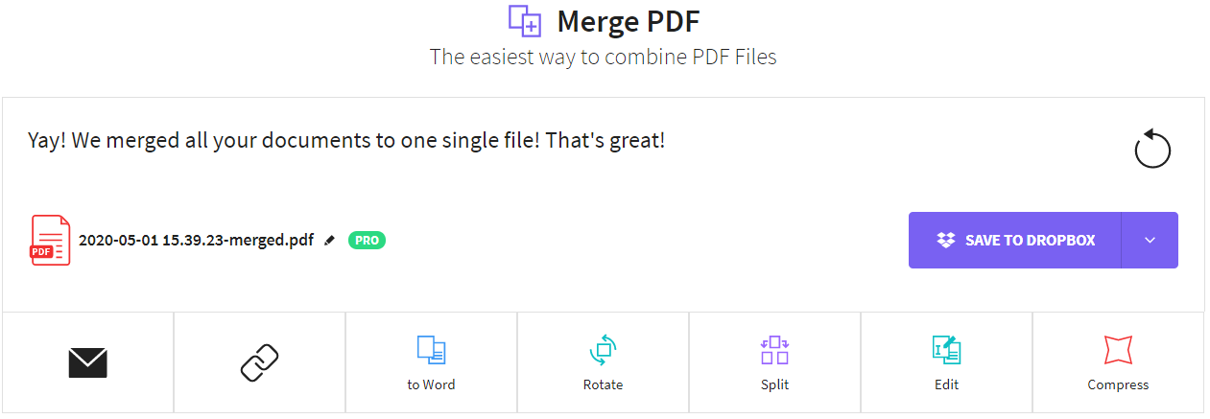

- Select where you would like the PDF file to be saved by clicking the dropdown menu arrow next to the “DOWNLOAD” button. (NOTE: I would recommend you save it to your computer, not a cell phone, not Dropbox or Google Drive)
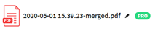
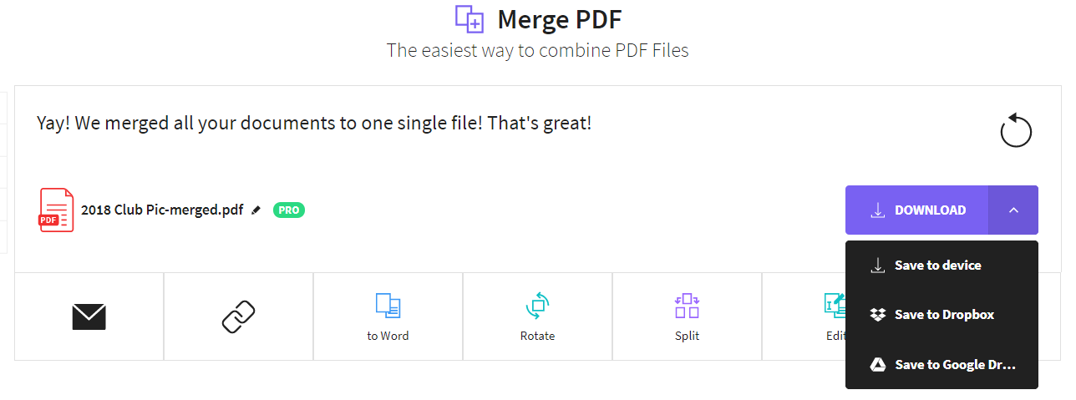

- Again, on a computer, you can upload the PDF file to the appropriate assignment in Teams OR
email the PDF file to Mrs. Reed ONLY IF it is an assignment that was assigned and returned in class prior to the closure (i.e. missing work that does not have an assignment set up in Teams).

