Health Class Facts

Serving Size 32 students Mrs. Cheryl Reed, MEd, ATC/L, NBCT
Servings Per Class 1 www.mrsreedsclass.weebly.com Room 1306
Amount Per Serving Office Hours:
Calories 0 Calories from Fat Before School and/or B Lunch
________________________________________________________________________% Semester Value*
Total Course Grade 5g 100%
Coursework 40%
Assessments 20%
“True to You” Project 20%
Final Exam 10%
Employability Skills 10%
Course Content 10g 100%
What is Health? 10%
Social Health 10%
Citizenship 10%
Environmental Health 10%
Mental Health 10%
Sexual Health 10%
Substance Abuse 10%
Nutrition 10%
Safety and First-Aid/CPR 10%
The Human Body 10%
Vitamin A 93-100% • Vitamin A- 90-92% • Vitamin B+ 87-89% • Vitamin B 83-86% • Vitamin B- 80-82% • Vitamin C+ 77-79% • Vitamin C 73-76% • Vitamin C- 70-72% • Vitamin D+ 67-69% • Vitamin D 63-66% • Vitamin D- 60-62% • Vitamin F <60%
_______________________________________________________________________________________________________________________________________
* Percent Semester Values are based on a 96 day course schedule. Your semester values may be higher or lower depending on our extra school day needs.

Ingredients: Current information, (media, newspapers, Internet, articles), group work, challenging labs, hands-on activities, collaboration, cooperation, best efforts, fun, respect, open discussions, health issues, high expectations, charged atmosphere and Spartan Power (derived from student body and faculty)

Other Important Information…

Materials/Resources Needed for Class
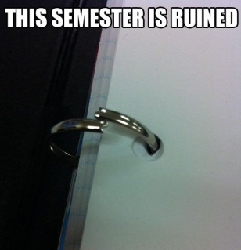
- A 1-1½” binder to be used for Health (preferably used; can be stored in classroom cabinet)
  - Table of contents (provided)
  - 6 tabbed section dividers (can be used or homemade)
  - Approx. 20-30 sheets of college-ruled, loose leaf paper in journal section of binder (no spiral bound notebooks or composition books please)
- Writing utensils of choice, though pencil is encouraged
- We use an in-class set of texts, therefore, textbooks will not be checked out to students (copies of our class text can be referenced/checked out at the library)
- Students are encouraged to have their student planners with them daily to record assignments and important dates

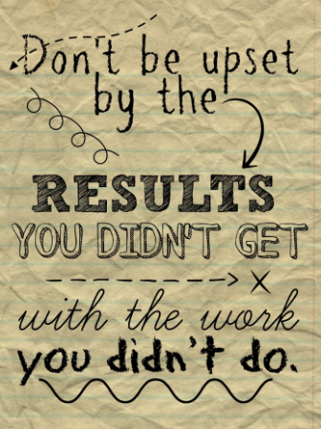
Coursework
Students should strive to do their very best on assignments and class work as they often constitute skills necessary to sustain a healthy lifestyle. Assignments are expected to be complete and handed in on time. Assignments may be scored for completion, for quality relative to that of their peers in class and/or for accuracy. Special attention is frequently given to detail, thoughtfulness and/or thoroughness in evaluating student work. It is the student’s responsibility to get any missed assignments/information from the whiteboard, website and/or their classmates after an absence and submit completed work in accordance with the student handbook. Assignments submitted after a due date are eligible for full credit so long as a valid Universal Pass accompanies it and it is submitted on or before Friday, January 19, 2018.

New! Coursework Remediation
In an effort to facilitate student learning and success, some assignments (and possibly assessments) may be eligible for remediation if the score earned on a particular assignment is below a C- (<69.5%). Eligibility may vary from assignment to assignment depending on the learning objective(s) of each assignment. For an assignment to qualify for remediation it must be submitted by its original due date and be at least 90% complete. Eligibility criteria may change as this new policy is implemented. If the opportunity for remediation is not supporting student learning, this policy may be altogether revoked.

Assessments
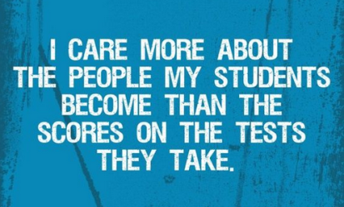
A variety of assessments are used to evaluate student learning. If a student is absent for an in-class assessment, it is the student’s responsibility to make an appointment with the instructor for before or after school. Make-up assessments are not typically given during class time. Assessments can be made up throughout the semester until Friday, January 19, 2018. Assessments not made up by then will be scored as a zero. Click here, for helpful note taking and study tips.

“True to You” Semester Project
All health classes participate in a leadership based project. Specific information regarding the “True to You” project can be found in the project outline file on the course website. Universal Passes may not be used on “True to You” projects submitted after the due date below, no exceptions. If a student is going to be absent due to illness or other personal reasons, an able person must turn the assignment into the office on or prior to the due date. Due Friday, January 19, 2018.

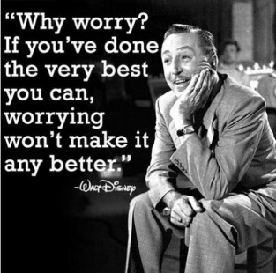
Semester Final
The final is comprehensive and will consist of at least 100 multiple-choice questions. It is strongly recommended that students keep all notes and handouts organized and kept together not only for binder checks but for referral/studying at the end of the semester. Also, each unit is preceded with a list of unit learning objectives. Students should review each unit’s objectives to assess their understanding and retention of course content prior to the final exam.

Employability Skills
Employability reflects the punctuality, cooperation, participation and behavior of a student in class. As this is a CTE course, it is important to practice and model skills desirable of employees in a workplace. At the conclusion of each week, students will be evaluated on their “employability” based on whether or not they modeled the following (not an all-inclusive list):
- Absences are excused through the attendance office
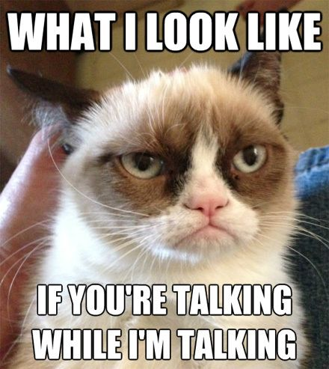
- Student remains in classroom unless dismissed by the teacher
- Student arrives to class on time or has a teacher’s/office note if late to class
- Appropriate language used (no cursing, bringing down others, shouting, etc)
- Professional behavior and demeanor towards others
- Participation in class activities/discussions
- Respectful of others and others’ property
- Follows instructions
- Follows lab safety rules
- Awake and engaged in class; contributes to class discussions/activities
- Does not vandalize school property (i.e. does not write on desks)
- Correctly stows technology after use
- Consumes only nutritious foods/beverages in class
- Keeps personal electronic devices in their bag until instructed to use them (see below)
New! Employability Skills Ratings
1—Rarely models professional workplace behaviors; considerable improvement in engagement,
collaboration, cooperation, productivity, punctuality, etc. needed to avoid dismissal
2—Occasionally models professional workplace behaviors; additional effort in engagement,
collaboration, cooperation, productivity, punctuality, etc. could be made
3—Consistently models professional workplace behaviors; contributes to create an
effective/efficient work environment through their engagement, collaboration, cooperation, productivity, punctuality, etc.

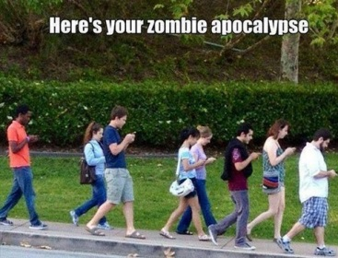
Personal Electronic Devices
Out of respect for themselves, the teacher and their classmates, students are asked not to have their electronic devices out or audible. Students are expected to adhere to ISD policies regarding personal electronic devices. From time to time it may be appropriate for students to use their electronic devices in class. Such opportunities will be communicated to students or students may ask the teacher if it is appropriate to use them. Unauthorized use of electronic devices may result in confiscation of the device and a loss of employability points.

Absences
Students are considered absent if they arrive 15 minutes after class has begun, as per the student handbook, whether excused or not. Absences may be excused through the attendance office by a parent/guardian over the phone or by a written note (excludes events/activities in which an absence pre-arrangement form is completed or is school hosted like sports/clubs). If a student will be absent later in the school day, a parent/guardian must contact the attendance office in advance to allow the student’s release from class.

Tardies
The tardy policy is strictly enforced as per the student handbook. Being tardy means a student is out of his or her seat as or after class starts as indicated by the network (computer) clock. Be aware that the school clocks can be out of sync with each other. Our classroom clock often runs fast.

Truancies
Students are truant if they leave class without permission, fail to show up to class but are obviously at school and/or leave the classroom when a substitute teacher is late or does not show up. There is no “15-minute rule” that students may leave if a teacher/substitute fails to arrive before hand.

Technology Guidelines and Policies
Technology is an important part of any education and this course is no exception. Students may be required to use a variety of programs throughout the course including, but not limited to, Windows Office applications, Google Drive and health apps. Students lacking a reliable computer, printer and/or internet access need to notify the instructor immediately. Please remember the school’s library is a resource for computers, printers and internet access, as are the ten computers in our classroom (before school or during B lunch).

The instructor cannot be held accountable for late work resulting from the following circumstances:
- A printer running out of ink or breaking down. Students are welcome to print things off from our classroom computers, Skyline’s library or public libraries.
- Home internet goes down. Use public/school libraries to access if need be.
- A computer or cell phone “crashing”. Use Dropbox or Google Drive to keep your school files safe and/or have backup copies.

Extra Credit Opportunities
Spartans Gone Green—Students can earn up to 2pts per Friday by bringing in the designated items
listed on their Gone Green Log. To earn these points, the student and their log must be present in class the day credit is awarded. It is not up for debate if the teacher does not approve the items for points. See the Spartans Gone Green Guidelines on the back of your Gone Green Log for further details. Applied to the Coursework Category.

Semester Unit Outline (subject to change)
- “What is Health?”
  - Who is Healthy?
  - Decision Making/Problem Solving Model
  - “True to You” Project Overview
  - Goal Setting
- Social Health
  - Relationships
    - Types of Relationships
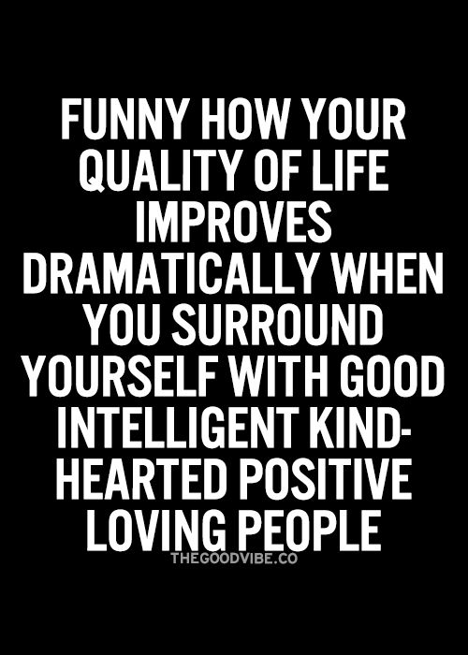
- Family Relationships
- Peer Relationships
    - Communication
    - Conflict, Violence & Abuse
  - Citizenship & The Environment
- Mental Health
  - Cognitive Development
  - Sleep
  - Good/Poor Mental Health
    - Self-Esteem and Self-Image
    - Self-Talk and Feedback
  - Abnormal Psychology
  - Depression & Suicide
- Sexual Health (FLASH)
  - Reproductive Systems
  - Sexual Transmitted Diseases
    - HIV/AIDS
  - Barriers and Safe Sex
- Substance Abuse
  - Categories of Substances
  - Alcohol
  - Tobacco
  - Addiction
  - Treatment & Prevention
- Nutrition
    - Macronutrients & Energy
    - Micronutrients & Water
    - Influences on Eating
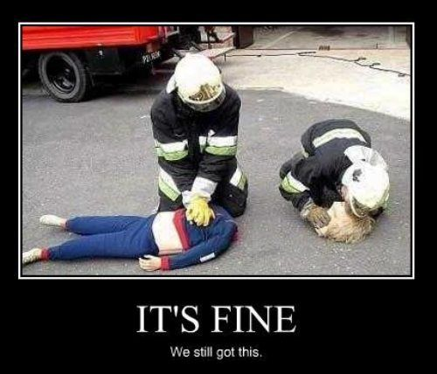
    - Diets and Good Measures of Health & Fitness
- Safety & CPR/AED/First-Aid
  - Safety
    - Exercise & Recreational Safety
    - Safety at Home
    - Natural Disaster Preparedness
    - Personal Safety
  - AHA Heartsaver Course
    - First-Aid
      - Injuries to Bones, Muscles & Joints
        - Splinting & Slinging
      - Sudden Illnesses
      - Burns & Wounds
        - Controlling Bleeding
        - Blood-borne Pathogens
    - CPR/AED (certification through this course to be eligible to earn Tech Prep credit)
      - Breathing Emergencies
      - Cardiac Emergencies

Tech Prep College Connections Program
This course is Tech Prep College Connections approved and articulated with Bellevue College and Lake Washington Technical College. Students who demonstrate proficiency of the college course competencies with a ‘B’ (3.0) grade or better will be eligible to earn college credit through the Tech Prep program. During the semester all of the college course competencies will be covered in class. Our agreement requires getting CPR/AED certified, which can be done at Skyline outside of the typical school day. Students must register online using the Statewide Enrollment and Reporting System (SERS) at http://sers.techprepwa.org and are also required to pay a non-refundable $46 consortium fee to earn college credit through the Tech Prep CC program (http://pay.techprepcc.org). Registration opens December 1st and closes June 15th each school year. Students must register for Tech Prep credit while they are enrolled in the high school program. Fee waivers are available upon request. Questions? Contact the Tech Prep College Connections office at techprep@bellevuecollege.edu or (425) 564-6158. Please also visit our website at: www.techprepcc.org.
Bellevue College: HLTH 292 First Aid & CPR Taking Action—4 CR
After completing this course, students should be able to:
- Recognize when an emergency has occurred
- Follow the appropriate plan of action for an emergency
- Provide care for injuries or sudden illnesses until professional help arrives
- Know how and when to call for emergency medical help
- Know how to prevent life style related illness and injury
- Provide background information, cardiovascular anatomy and physiology, coronary artery disease, risk factors in heart disease, prudent heart living and signals and actions for survival
- Identify methods for preventing unnecessary mortality from heart attack
- Describe the technical aspects of CPR
- Identify possible causes of airway obstructions and manage airway obstruction
Lake Washington Technical College: FTNS 120 Responding to Emergencies
Upon successful completion of the course the student will be able to:
- Recognize and handle an emergency, check the scene for safety, and assess the state of the victim
- Provide 1st responder care for life-threatening conditions or sudden illnesses
- Recognize the signals of a heart attack and how to give care
- Care for and prioritize injuries for various first aid situations

Leadership Opportunities
Through CLUB MED and FCCLA, both ASB sponsored clubs, health students have the opportunity to run for local, state and national offices, compete in state and national events related to health and apply for scholarships. Health students are encouraged to participate in these wonderful student leadership opportunities.

Teacher Expectations of Students
Students will respect themselves, their fellow students, classroom guests and the teacher at all times.
- Work hard and BE NICE!
- Keep your work organized so you can find documents easily
- Respect other people’s belongings, space and rights to a quality education
- Follow instructions provided by substitute teachers and guest speakers
- Do not draw on desks or otherwise vandalize school property
- Keep cell phones/iPods/MP3 players quieted and stowed in your bag during class…students will be told when they may use these items in class.

Students are responsible for turning in their assignments in on the date due.
- Use your student planner to keep a record of assignments and when they’re due
- Take ownership and responsibility for YOUR grade which is EARNED not given! Use Family Access to stay abreast of your progress in class. If there is a discrepancy, politely ask for clarification.
- Review the technology guidelines and policies above.
- E-mail the instructor immediately if you have a problem arise. Learning of a problem after a due date does not bode well for your case!
- Utilize resources available to you to stay on top of your coursework, like the course website.

Students are to be in their seats by the start of class as indicated by the network clock and not leave the classroom unless excused by the teacher.
- Remember the teacher dismisses class, not the clock
- Make sure your watch/cell phone is in sync with the network clock (the time on school computers; the classroom’s clock is often incorrect) which is the “official” time for the building
- Driving students: Leave home early enough to park and get to class on time!

Student are responsible for having with them all necessary materials needed in order to participate in class.

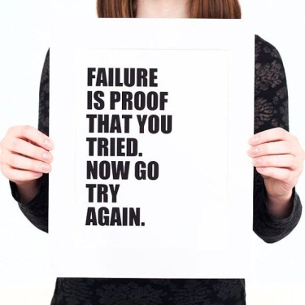
Students will act as responsible and professional members of the Skyline learning community.
- When struggling, seek help!
- Give yourself adequate sleep and good nutrition to perform your best!
- Remain organized to help manage your time and keep documents from “disappearing”
- Support your peers in their learning (study groups, tutoring a struggling student, etc), it will reinforce your own learning
- When using other people’s work or ideas, students are ALWAYS expected to cite their sources in MLA format as per the student handbook and academic integrity policy, giving credit where credit is due. This goes for pictures too! NOTE: Wikipedia is often NOT an acceptable source for this course.

Lab Safety Rules
During this course there may be experiment/lab opportunities involving chemicals and lab equipment. Most of the chemicals we use in class are safe and pose little to no threat to health. However, whether working with benign or hazardous materials/equipment, it is important to adhere to lab safety rules (classroom and school district) as if all labs/equipment are potentially dangerous.
- No horseplay! Horseplay will result in the removal from the lab and a zero on the assignment.
- Follow teacher instructions exactly—if you’re not sure about something, ask!
- Alert teacher to problems, equipment malfunction and/or injuries immediately
- Know how to use lab safety equipment (fire extinguisher, fire blanket, wash stations, etc)—we will cover the use and location of such equipment in class
- Wear safety goggles at all times when working with materials that could splash or otherwise get into the eyes
- Long hair should be pulled back (shoulder length or longer)
- Avoid awkward transfers—carry smaller quantities to your lab station
- Allow hot objects to cool or use appropriate protective equipment (gloves, clamps, tongs, etc)
- Carry chemicals defensively to avoid accidents—watch where you’re going and what other people are doing
- As our classroom is not a typical science lab, all personal belongings need to be at the front of the room to avoid tripping, destruction of property and other similar incidents
- The teacher will inform students how to properly dispose of chemicals/lab wastes
- Dress appropriately—No open toed shoes or baggy clothes
- Always leave your lab station clean and wash your hands

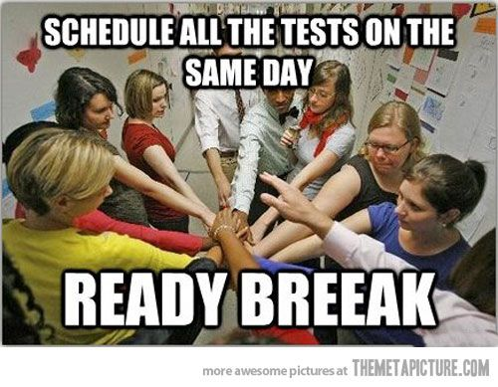
Student Expectations of Teacher
Students can expect the teacher to have genuine concern for and care about students as individuals, not just in the present but for their future.

Students can expect to have lessons delivered with enthusiasm and utilize a variety of formats to enhance student interest and learning.

Students can expect to have a teacher who is well organized and accountable for assignments turned in by students.

