DO NOT PRINT OFF THIS DOCUMENT

Health Binder Checklist

- Course materials are contained within a standard 3-ring binder; no binders with zippers, Velcro, binder covers, etc please
- BioCollage is present in the outer window of the binder or in a page protector within the rings of the binder
- Table of Contents is present (provided)
- Six dividers with tabs are present (can be homemade, Mrs. Reed has a tab punch that may be borrowed); section dividers should be in the order denoted on the Table of Contents
- Papers are punched & secured in the rings of the binder, in their appropriate sections (see Table of Contents for details)
  - Repair papers with torn holes with tape and repunch
  - No papers inside pockets of binder and/or dividers
  - No papers/items from other courses in binder
  - Extra notebook paper goes in the Journal section
- Notes are present, completed and in numeric order by page number (like a book)
- All journal entries are present (in chronological order, earliest to most recent) and thoroughly completed
Journal Entry Guidelines:
- Journal entries constitute the bulk of your binder check score so make sure they’re thoughtful, thorough and, well…present!
- Clearly head each journal entry by number (i.e. Journal Entry #3); it would be helpful to highlight, underline or box each journal entry header for ease of identification
- Write small (not to be confused with less) and use both sides of your paper to reduce paper consumption
- If you’re absent or could not finish an entry in the time provided in class, all journal entry prompts can be found on the course website under “Course Files by Unit” and then “Miscellaneous Course Files”
- NOTE: Journal entries will be kept confidential unless language/illustrations suggest abuse of a student is occurring and/or a student is threatening to hurt them self and/or somebody else (teachers, administrator, coaches, etc are mandatory reporters by law)
Journal Entry Prompts

Journal Entry #1: 16 Personalities Assigned 9-11-18

Refer to the “16 Personalities Instructions” file under Course Files
on the course website to complete this journal entry. The website you’ll use for taking the personality test is:
https://www.16personalities.com/free-personality-test
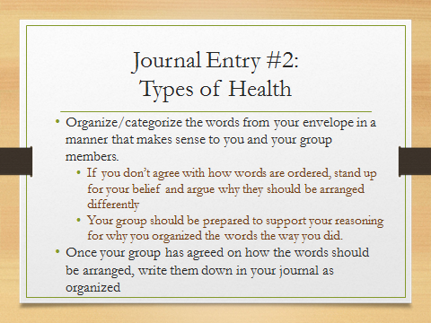
Journal Entry #2: Types of Health Assigned 9-12-18

Words needed are below!

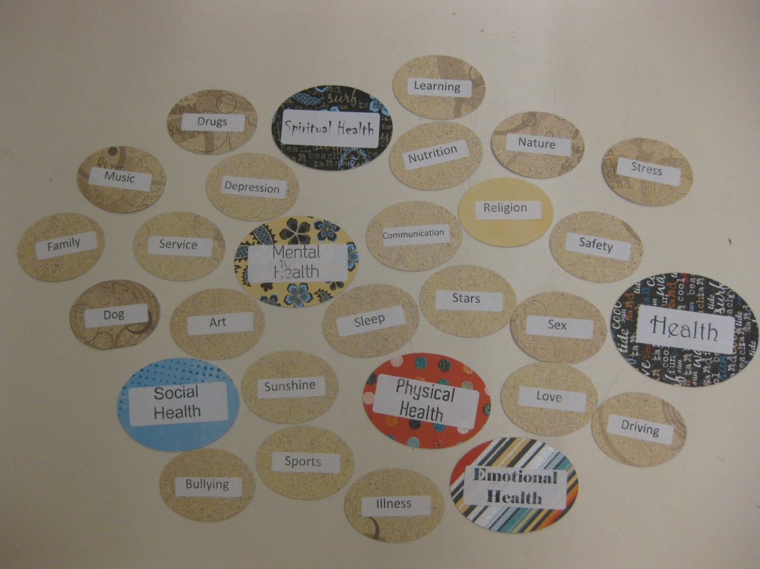

Journal Entry #3:

Journal Entry #2: 16 Personalities Test Assigned: 2-5-18

