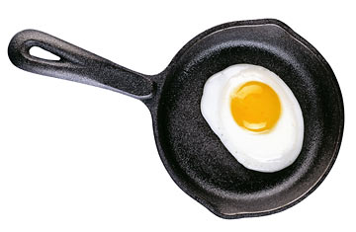
Substance Abuse

Why “Substance Abuse” vs. “Drugs & Alcohol”?
- “Drugs & Alcohol” suggests the only things that are abused are illegal drugs & alcohol.
___________________________________________________________________________
- “Drugs & Alcohol” suggests alcohol is not a drug or is considered separate from other drugs.
__________________________________________________________________________________________
- The unit’s focus is ___________________________________________________________________________.
General Substance Abuse Terminology

- ____________________________—Proper consumption/application of a substance or product as it is intended

- ____________________________—Improper consumption/application of a substance or product; generally unintentional or accidental

- ____________________________—Intentional consumption of substances to achieve a desired effect and/or are known to cause health risks/disease, accidents, death, etc.

Examples of Use, Misuse and Abuse
Substance | Use | Misuse | Abuse
Medications
Inhalants
Alcohol
REMEMBER: Even substances used as intended and/or correctly can pose a threat to one’s health.

- ____________________________—requiring more and more of a substance to get a desired effect(s)

- _________________________________—a person thinks or believes they have to have a substance in order to behave in a particular manner or feel a particular way (particularly socially)

- _________________________________—the body cannot physically function without the presence of a given substance

- ____________________________—the state of physical and mental dependence on a substance

- _________________________—the process through which a person stops using a substance; various
signs and symptoms can result, including possible death

- _________________________________—the interaction of two different substances resulting in a greater overall effects

- ____________________________—results from excessive ingestion of a substance that could lead to coma or death
Abused Substances Terminology/Categories

- ____________________ Drugs or “Street Drugs”—substances that are classified illegal by state and/or federal (DEA) law; cocaine, heroin, fentanyl, LSD, ecstasy

- _______________________ Drugs—drugs created in a laboratory that are not organic in nature/origin; methamphetamine, some inhalants, bath salts, GHB

- ____________________ Drugs—may have color, symbols/shapes or flavor to entice abusers; ecstasy

- ____________________ Drugs—drugs commonly seen at clubs or raves; rohypnol, GHB

- ____________________—substances inhaled into the respiratory system for desired effect(s)

- ____________________ Drugs—substances that may lead to the use of other abused substances, a controversial term; possibly ethanol alcohol, marijuana, caffeine
- __________________________________ (OTC) Drugs—medications that can be purchased without a prescription; acetaminophen, ibuprofen, aspirin, ephedrine/pseudoephedrine, etc.

- _______________________ (R_{x}) Drugs—Require a R_{x} from a licensed medical professional; Adderall, Zoloft, Oxycodone, Vicodin, etc.
Abused Substances by Effect

- Depressants—_________________________ the CNS; Ethanol Alcohol, GHB

  - ____________________________—create a sedative effect; sleep aids, rohypnol

- ____________________________—dulls senses, relieves pain, induces sleep; Oxycontin, heroin, Vicodin, fentanyl, morphine

- Stimulants—_______________________ the CNS; methamphetamine, cocaine/crack, nicotine, caffeine (coffee, energy drinks, soda, chocolate, caffeine pills, etc.)

  - _________________________—frequently R_{x} drugs sold/taken illegally; Adderall, Ritalin

- __________________________—produce hallucinations; LSD, mescaline, PCP, inhalants (paints, cleaners, glues, aerosols, air fresheners, markers, etc.)

- __________________________—a category of its own as it can have depressant, stimulant and/or hallucinogenic properties depending on the purity, the abuser’s own physiology, amount, etc.

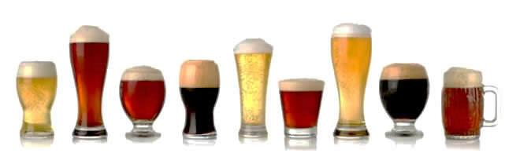
- __________________________—a synthetic derivative of the male hormone testosterone

Alcohol
- Medically/scientifically termed _____________________________________

- A depressant, organic in origin, legal and THE _________________________________

- ___________________________—physical and mental impairment resulting from the use of alcohol; impaired judgment, slurred speech, blurred vision, depression, flushed cheeks, unconsciousness, vomiting, etc.
Short-term Effects of Alcohol

- _____________________—slows the CNS, thoughts are disorganized, memory/concentration dulled, decision making affected

- _____________________—responsible for filtering the blood of alcohol and converting it into water, carbon-dioxide and energy (metabolism)

- _________________________—carries the alcohol to the rest of the body, dilates vessels, heat loss

- _________________________—increases heart rate and blood pressure, abnormal heart beats

- _________________________—causes kidneys to increase urine production, resulting in frequent urination and ultimately dehydration

- _________________________—immediate absorption through the stomach, increases secretion of gastric juices resulting in stomach irritation
Long-term Effects of Drinking
- Alcoholism
  - Reverse Tolerance—______________________________________________________________________
- Chronic liver problems (i.e. fatty liver, cirrhosis, hepatitis)

- Unplanned Pregnancy/STD’s—_________________________________________________________________

- Inhibits the metabolism of fat—_________________________________________________________________
Alcohol Consumption
- ____________________ drinking is defined as consuming 1 drink/day for women, 2 drinks/day for men

- ____________________ drinking is defined as consuming 8+ drinks/week for women, 15+ drinks/week for men

- ____________________ drinking, the most common form of excessive drinking, is defined as consuming 4+
drinks for women and 5+ drinks for men during a single occasion
Driving Under the Influence (DUI)

- BAC—___________________________________________________

- _________% is the legal limit (_________________________________________________________________)
_________% for minors (_____________________________________________________________________)
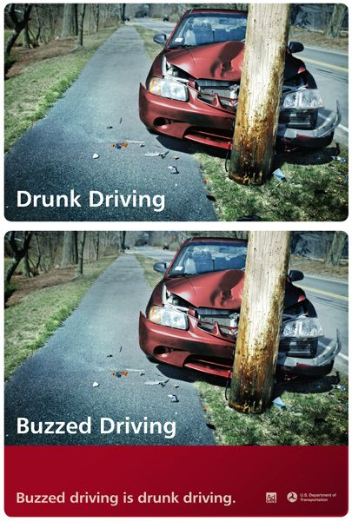
- Factors that influence a person’s BAC:

  - ___________________________

  - ___________________________

  - ___________________________

  - ____________________________________________________

  - ____________________________________________________
- Signs of intoxication can begin at a BAC of .02
- Physical manifestations of DUI:
- Reduced ability to judge distances, speeds & turns
- Added forgetfulness to take precautions such as using turn signals or putting on a seat belt
- Reduced ability to judge accurately one’s own capabilities and limitations
- Increased tendency to take risks
- Reduced ability to concentrate
- S l o w reflexes
- Legal ramifications for DUI:
- Possible confiscation of driver’s license
- Arrest and possible trip to jail, court appearance and fine
- Possible suspension of driver’s license
- Possible mandatory jail sentence
- Higher insurance rates
- Possible lawsuits
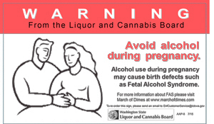
- Cost of bail
Alcohol and Pregnancy

- ______________________________(FAS)—a condition in which a fetus has been adversely affected mentally and physically by its mother’s alcohol use during pregnancy
  - Alcohol in the mother’s blood is directly sent to the fetus like blood would carry alcohol to any organ

  - FAS is 100% ______________________, yet each year roughly 40,000 FAS babies are born in the U.S.
  - In 1988, the US Senate passed the bill that requires a warning label about FAS on all alcoholic beverages
Tobacco—Nicotine is a legal, organic, stimulant
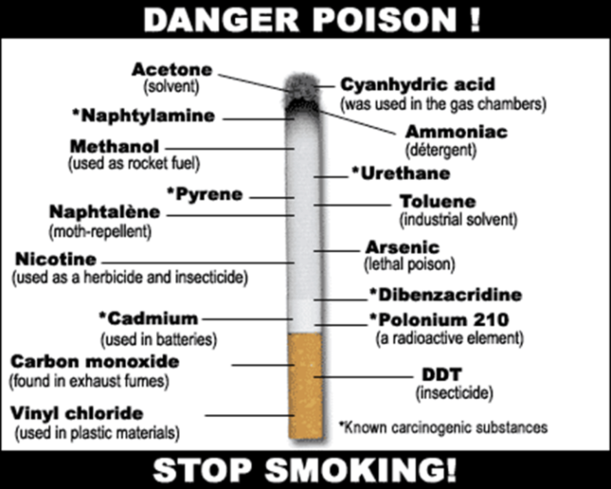
Forms of Tobacco
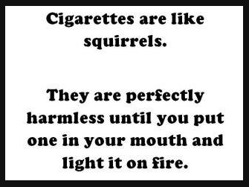
- Cigarettes
- Cigars
- Smokeless Tobacco
  - Chew/Snuff
  - Vaping/Hooka
- Specialty Cigarettes
- Pipes
Short-term Effects
- Appetite suppression
- Increased heart rate
- Constricts blood vessels=increases blood pressure
- Decreased urine output
- Decreased reflex time
Long-term Effects

- __________________________________—irritation of the bronchi resulting in coughing and increased mucus secretion; Smoker’s Cough
- ____________________________—destruction of the alveoli

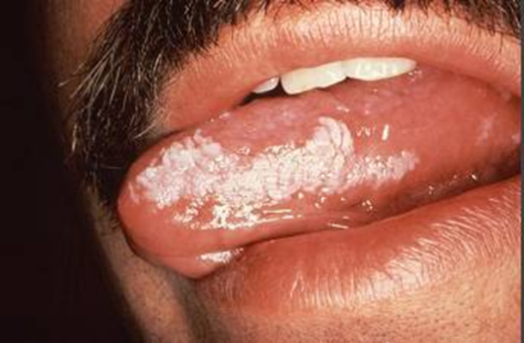
- ____________________________—starts in the bronchi, moves to the lungs; cancer cells can enter the lymphatic system and reach other organs
- Makes heart work harder, speeding up pulse
- Constricts the blood vessels resulting in higher blood pressure and poor circulation
- Plaque build-up in blood vessels

- ______________________________—thickened, white, leathery appearing spots on the inside of a smokeless tobacco user’s mouth that can develop into cancer of the mouth
Secondhand Smoke
- There is no safe amount of secondhand smoke
- Secondhand smoke has been known to cause SIDS, ear infections, respiratory infections and more frequent/severe asthma attacks in children
- It causes heart disease, lung cancer and stroke in adults
- Smoking sections do not protect you from secondhand smoke
- The most common exposure occurs in homes & worksites
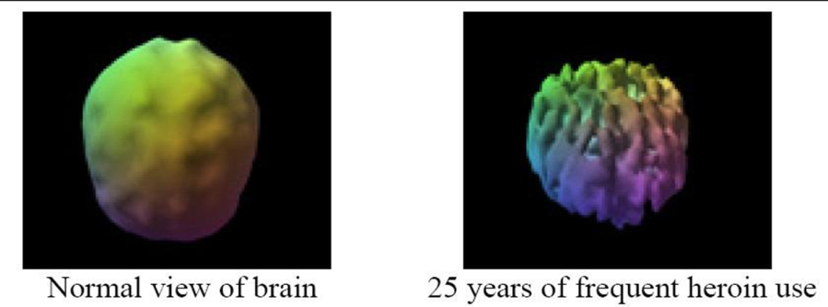
Addiction
Disease or Lack of Will Power?
- Advances in research of the brain indicate that addiction is a disease; that is, substance abuse can lead to the brain’s actual change in structure and function
- As there are structural and functional changes, it makes it difficult for a person to overcome the urges to abuse a substance
“Drugs” are…
- Chemicals that tap into the brain’s neural pathways and disrupt the way nerve cells normally send, receive and process information
- Two ways they do this:
- Imitating the brain’s natural chemical messengers (neurotransmitters, like dopamine)

- __________________________ the “reward circuit” of the brain
Pleasure to Pain
- Nearly all drugs directly or indirectly target the reward system, flooding it with ____________________
- Dopamine is a neurotransmitter that controls movement, emotion, motivation and feelings of pleasure
- Increased release of dopamine results in a euphoric state, ultimately “teaching” a person to use a substance
Addiction
- Over time, the brain adapts to the overwhelming surges in dopamine by producing _______________ dopamine and/or dopamine receptors
- The reward system is inhibited as a result
- The decrease in pleasure compels addicts to continue the abuse in an attempt to bring the dopamine levels back to normal and thus, the feelings of pleasure return
- Images of the brain indicate that addicts show changes in areas of the brain responsible for

_________________________________________________________________________________________
- This can lead an addict to violence, crime and other adverse behaviors in order to attain the substance, regardless of the repercussions
Who is at risk?
- There is no single factor that can predict a person may become an addict
- Chances are influenced by:

  - ___________________________—heredity, gender, ethnicity and mental disorders

  - ___________________________—relationships (peer-pressure, sexual/physical abuse, stress and lack of
parental involvement) and socioeconomic status
  - ___________________________—the earlier the abuse begins, the more likely it will lead to addiction
Treatment/Recovery
- No single treatment is appropriate for all individuals
- Treatment should be readily available so those who want to be treated can find it with relative ease

- Treatment should revolve around the person’s ________________________________, versus just the addiction problem
- Treatment should be re-assessed often and modified to meet the person’s changing needs
- For treatment to be effective, a person must stick with their program to its completion

- _____________________ and other behavioral therapies are critical components to treatment

- For certain types of addictions, ______________________ are an important element of treatment, combined with counseling/behavioral therapy
- Medical management of withdrawal does little to change long-term drug use, thus it’s not over just because withdrawal symptoms are gone

- Treatment does not need to be ______________________ to be effective (interventions)
- The possibility of drug use during treatment cannot go unabated (frequent drug testing)
- Treatment programs should provide assessment for HIV/AIDS, hepatitis B and C, tuberculosis and other infectious diseases
- As is the case with other chronic, relapsing diseases, recovery from drug addiction can be a long-term process and typically requires multiple episodes of treatment and other forms of continuing care

- Quitting “__________________________” can be dangerous (withdrawal syndrome) and is often unsuccessful
- Treatment requires family members/friends to be involved and active in the addict’s recovery
Kicking the Nasty Habit

- Set a specific _________________________ and stick to it
- Set short-term goals to reinforce one’s decision to quit
- Decide what method or methods to use to quit (gums, patches, Rx drugs, etc.)
- Get the environment ready for a smoke-free lifestyle
- Have a support system to help through the process
Resources for Help
- Teachers, Counselors, Hotlines, Parents, Coaches, SRO
- TeenLink Directory (PDF version on website)
- http://findtreatment.samhsa.gov/
Prevention

- ____________________________________
- Engage in physical activity
- Volunteer work
- Join a youth group
- “Just say ‘no’”—_____________________________________________________________________________
- Educate yourself about the physical/emotional/mental/legal consequences of substance abuse
- Try intervention techniques with a friend who is using—peer pressure can be positive!
Choose to be Alcohol Free
- Refusal skills
- Weigh the risks…Did somebody say, “Decision-making model???”
- Avoid “friends” who drink or who would not respect your decision not to

- Avoid situations that could put you at risk of drinking or “_____________________________________”
- Make a deal with your parents/self

Long-term Effects
Short-term Effects
Classifications
Method(s) of Consumption
Forms of Substance
Slang and/or Street Names
Substance | Amphetamines | Anabolic Steroids | Bath Salts (Synthetic Cathinones) | Caffeine | Cocaine | Ecstasy | Fentanyl | GHB
Long-term Effects
Short-term Effects
Classifications
Method(s) of Consumption
Forms of Substance
Slang and/or Street Names
Substance | Heroin | Inhalants | LSD | Marijuana | Mescaline | Meth | Rohypnol | Synthetic Marijuana (K2/Spice)

