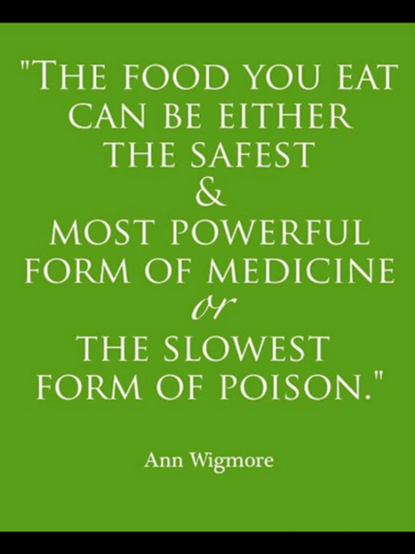
Nutrition
The Six Essential Nutrients
MACRONUTRIENTS—________________________________________

1. ___________________________________ (CHO)

- Most important energy source; _______ calories per gram; inexpensive

- ____________% of total calories should come from CHO; 10% or less of total CHO should come from simple sugars
- Monosaccharides or “Simple Sugars”: Glucose, Galactose, Fructose
- Disaccharides: Maltose, Sucrose, Lactose
- Polysaccharides or “Complex CHO”

  - _____________________ and _____________________ in plants;

____________________ in animals
  - Glycogen is the storage form of glucose found in skeletal muscle (approx. 350g) and the liver (90g)

2. ___________________________________

- Lipids—generic term for all fats; ______ calories per gram

- ____________% of calories should come from fat

- ________________________________—storage tissue of fat

- Cholesterol—__________ (bad) vs. _________ (good)

- ___________________________ (TG)—composed of glycerol and 3 fatty acids; glycerol base is the part broken off and converted to glucose for energy production:

  - Saturated—Each carbon has its full complement of _______________________; solid at room temperature; animal sources; hard to break down and increase blood cholesterol

  - Monounsaturated—____________ double bond missing, not completely full of hydrogen; liquid at room temperature; vegetable sources

  - Polyunsaturated—____________ double bonds missing; liquid at room temperature; vegetable sources; easiest to break down

3. ____________________________________

- _________________ important energy source; _______ calories per gram.

- _____________% of total calories should come from protein (most people get more than RDA)
- Made up of amino acids:

  - _______ Essential Amino Acids—_______________________________________________________________

  - _______ Non-Essential Amino Acids
- Critical for many functions (tissue growth and repair, antibodies, enzymes, etc) outside of energy; Note: Time eaten may be more important than amount eaten in terms of muscle/tissue repair
Metabolism
- Chemical reactions that occur in an organism for the sake of energy production
- Two types:
  - ______________________________—the decomposition of “stuff” in the body
  - ______________________________—the synthesis of new “stuff” in the body
Where Our Energy Goes

- ___________% Basal Metabolic Rate or Resting Energy Expenditure (REE)

- 5-10% Thermal Effect of Food (digestion)

- ___________% Physical activity

- A calorie is _________________________________________________________

micronutrients—___________________________________________________________

4. ___________________________________
- Vitamins aid various processes throughout the body and are particularly important for chemical reactions
- Can protect against oxidative damage (anti-oxidants) by capturing free radicals, thus reducing risk of cancer
- Two classes of vitamins:

  - _____________-Soluble Vitamins (difficult to overdose on); _____ vitamins and vitamin _____

  - _____________-Soluble Vitamins (risk of overdose is higher); vitamins _____, _____, _____ & _____

5. ___________________________________
- Act as catalysts for many chemical reactions; come from plant and animal food sources
- There are 24 minerals needed for good health, including Ca, Na, K, Mg, P, Cl, S and trace minerals (i.e. iron, iodine and copper)
Neither a Macro- nor Micro- Nutrient
6. ___________________________________
- Necessary for chemical reactions (such as hydrolysis)
- The primary component of blood (plasma) and interstitial/cellular fluids
- Lubricates your joints (synovial fluid)
- Body temperature regulation (sweating)
- Maintains homeostasis
- Amount requirements vary from person to person; urine color (a pale yellow as opposed to clear or dark yellow/amber) and thirst are key indicators of hydration; when thirsty drink WATER

- Can live about ______ days without water (as opposed to ~______ days without food)
- Dehydration may result in the following: muscle cramps, headaches, fatigue, decreased blood volume, constipation, poor complexion, stiff joints and hallucinations
Eating Behaviors and Food Choices
Influences: People, Medical Needs, Geography, Occasions, Holidays, Culture, Mood, Time, Money, Advertising…the list goes on and on!
- You CAN eat cake, candy, French fries, etc.! You just need to keep it in moderation
- To improve your meals, try substituting healthier ingredients when preparing your favorite foods/meals
- To manage how much you eat:
  - Eat enough food to cease hunger, not appetite
  - Know foods higher in fiber/protein combat hunger better than refined
  - Use a smaller plate or bowl
  - Have a glass of water or half a piece of fruit before a meal
  - Eat slowly (put your fork down between each bite)—It takes approximately ________ minutes for your brain to realize you are full
  - Prepackage your servings
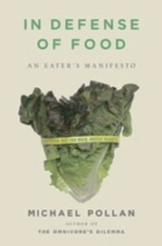
Michael Pollan’s “Eating Guidelines”:
- “Don’t eat anything your great grandmother wouldn’t recognize as food”
- “Eat mostly plants, especially leaves”
- “You are what what you eat eats”
- “Eat wild foods when you can”
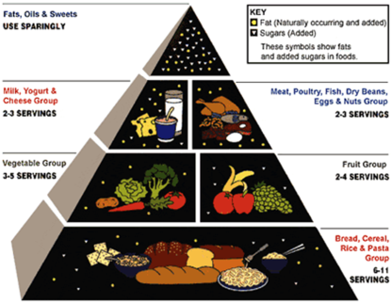
- “Pay more, eat less”
- “Do all your eating at a table”
- “Try not to eat alone”
- “Cook and, if you can, plant a garden”
Dietary Guidelines: Friend or Foe?
The Food Pyramid (USDA)—1992
- Tried to emphasize groups on bottom as a “foundation” to a balanced diet
- One-size-fits-all serving suggestions; what constitutes a “serving”?
- Does not denote between “good” and “bad” fats/oils and carbohydrates
WARNING: Guidelines were influenced by the food industry
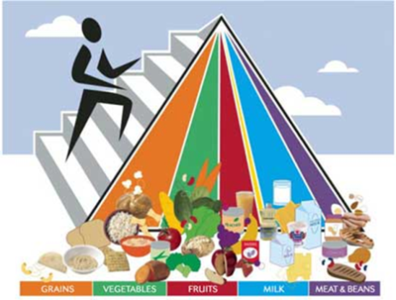
MyPyramid (USDA)—2005
- Tried to get away from the cookie cutter food pyramid; more

__________________________ based on age, sex, height, weight and activity level.

- Accounted for _______________________________
- Too complicated for users to understand; lots of subtle nuances
WARNING: Guidelines also influenced by the food industry

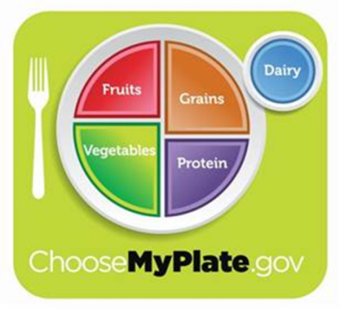
MyPlate (USDA)—2011
- Still avoids cookie-cutter; personalized
- Emphasizes balancing calories
- Enjoy food, but eat less
- Avoid oversized portions
- ½ your plate should be fruits and veggies
- Drink fat-free or 1% milk
- Make half of your grains, whole grains
- Limit foods high in fat, sugar and sodium
- Drink water instead of sugary drinks
- Physical activity not emphasized
WARNING: Still influenced by the food industry

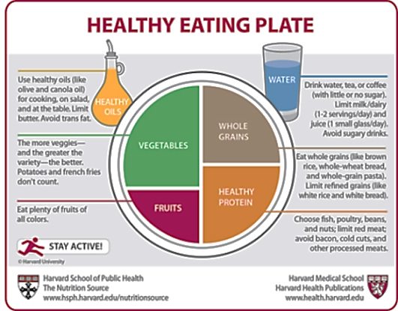
Healthy Eating Plate (Harvard School of Public Health)—2011

- _____________________________________________________________
- _____________________________________________________________
- _____________________________________________________________
- _____________________________________________________________
- _____________________________________________________________
- Based exclusively on the best available science; not subject to political/commercial pressure from food industry lobbyists

Food Packaging: Claims & Terms
Claim/Term | Definition/Description
 | The food is raw, unprocessed, contains no preservatives and has never been frozen or heated
 | Calories have been reduced by at least 1/3, or the fat or sodium by at least ½
 | The food contains 25% less of a nutrient or of calories than a comparable food
 | Product contains no amount, or only trace amounts, of fat, cholesterol, sodium, sugars or calories
 | Low in fat, saturated fat and limited amounts of cholesterol and sodium
 | Minimally processed with no artificial or synthetic ingredients; no FDA definition, but working towards one
 | No growth hormone/antibiotics used, produced without using most conventional pesticides, fertilizers with synthetic ingredients or sewage sludge, bioengineering, or ionizing radiation
 | Proteins formed when white, rye, barley and/or crossbred hybrids of such grain flours are mixed with fluids and physically manipulated; to be considered “free,” product must contain less than 20 parts per million (ppm) gluten
 | Chemically/enzymatically hydrogenated unsaturated fats; rarely found occurring naturally; partially hydrogenated oils are the major source in the food industry
 | Genetically modified organism; an organism whose genetic material has been altered to achieve a particular goal
Food Packaging: Nutrition Facts Label
- Established by the FDA; changed in June 2018

- ______________________________________________________(RDA)—the amounts for various nutrients recommended to prevent deficiencies and excesses in most healthy people

- _____________________________________ (%DV)—per day for a 2,000C diet; <5%=low and >20%=high for a given nutrient

Food Packaging: Ingredients List
- Ingredients are listed in order of weight (most to least); pay attention to the first 3-5 ingredients…are they sugar, fat, salt/sodium and/or unrecognizable ingredients?
- Can be used to determine if the product likely contains GMO’s
- It can identify hidden sugars (high fructose corn syrup, dextrose, maltodextrin, etc.) and trans fats (partially hydrogenated canola oil); the nutrition facts label may be misleading regarding these ingredients
- Provides food additives—substances added to food intentionally to produce a desired effect:

  - _______________________________________ (i.e. gums, waxes, gelatins; hydrogenated)
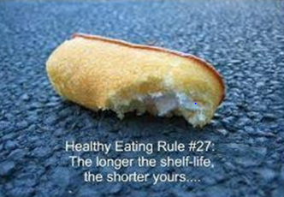
  - _______________________________________ (i.e. vitamins, minerals, protein)

  - _______________________________________ (preservatives)

  - _______________________________________ (i.e. natural flavor, Red 4)
  - Control food’s acidity (i.e. alkali)
  - Help age foods

Investigating Food Packaging Worksheet Toolkit:
- % Calories from Fat (30% or less is recommended) =
Calories from Fat ÷ Total Calories
- Complex Carbohydrates (or “Other Carbohydrates”; 50% or greater is
recommended) = Total Carbohydrates - (Sugars + Fiber)
- % Daily Values are to add up to 100% for the day
- The table at the bottom of the nutrition label is universal to all foods and food products (not present on new label)
- Ingredients are listed in order of amount/weight, greatest to least
- Potential allergens identified by the food company are bolded at the end of or beneath the ingredients list
- 1g protein or CHO = 4 calories; 1g fat = 9 calories
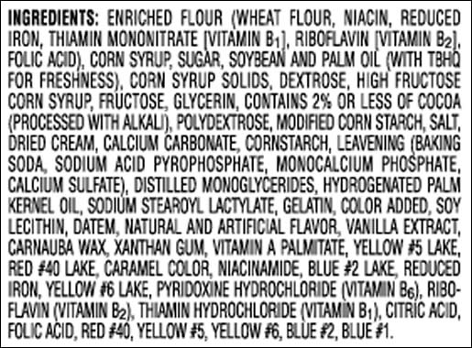
- GMO’s = any corn, soy, wheat, rice, etc. ingredient or derivative is likely a GMO unless the product is certified organic
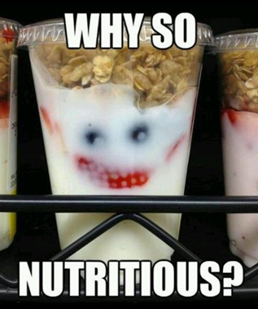

Key
Green = probable GMO
Yellow = added nutrients
Blue = color additive
Red = texture additive
Purple = preservative additive
Orange = acid control additive
Pink = flavor additive
Red Circle = trans fat
Blue Circle = hidden sugar
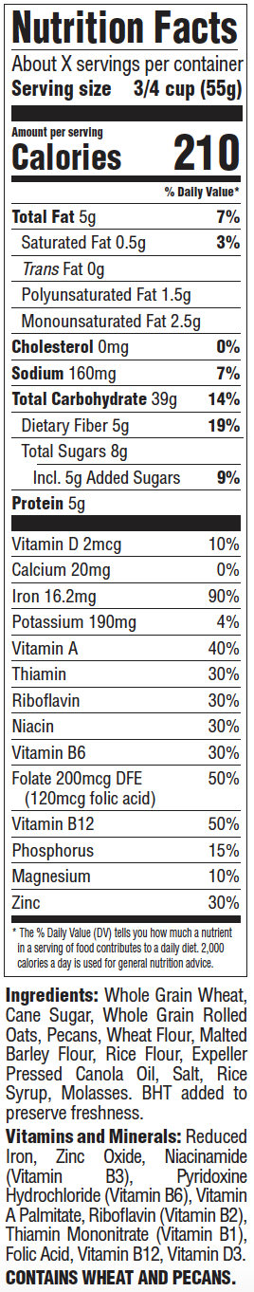
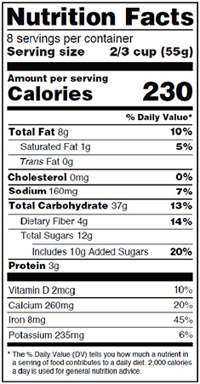

Grocery Shopping with Michael Pollan:
- “Avoid food products that make health claims”
- “Shop the peripheries of the supermarket and stay
out of the middle”
- “Get out of the supermarket whenever possible”
- “Avoid food products containing ingredients that are:

  - __________________________________________

  - __________________________________________

  - more than ________ in number or include

  - __________________________________________ and other hidden forms of refined sugars”
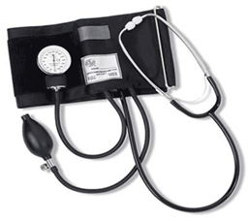
Good Measures of Health/Fitness

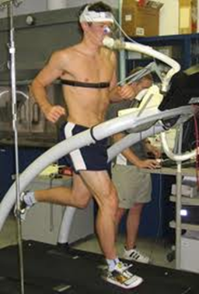
- ________________________________________
- Basic Medical Diagnostics:
  - ______________________________________
  - ______________________________________
  - ______________________________________
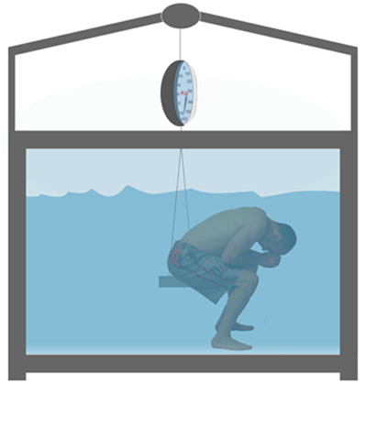
  - ______________________________________
  - ______________________________________
- ________________________________________
- ________________________________________
- ________________________________________
- ________________________________________
- ________________________________________
- ________________________________________
- ________________________________________
Fad Diets
- Atkin’s Diet, South Beach Diet, Grapefruit Diet, Liquid Diet, Cereal Diet, Cabbage Diet, dietary programs, supplements, starvation, etc…
- Reasons fad diets don’t work and/or aren’t healthy: ________________________________________________________

____________________________________________________________________________________________________

________________________________________________________________________________________________________________________________________________________________________________________________________
The AMAZING “Secret” Diet
How to lose FAT weight healthfully…

- _____________________ caloric intake and ____________________ caloric expenditure (i.e. if you eat 2,000 calories, burn 2,500+ to utilize stored glycogen and fat)
- Modify personal eating behaviors (see “Eating and Food Choices” section)
- Choose mono-/poly- unsaturated fats, limit saturated fats and avoid trans fats
- Remain hydrated by drinking W-A-T-E-R (aim for a pale yellow urine color)

- Do _________________________ activities mixed with some strength training (more muscle means more calories can be burned)
- The rule of thumb for weight loss/gain is to lose/gain no more than _________ pounds a week

